Iris Recognition using Machine Learning Technique

In this project to recognize person from IRIS we are using CASIA IRIS dataset which contains images from 108 peoples and by using this dataset we are training CNN model and then we can use this CNN model to predict/recognize persons. To train CNN model we are extracting IRIS features by using HoughCircles algorithm which extract IRIS circle from eye images. Below screen shots showing dataset with person id and this dataset saved inside ‘CASIA1’ folder

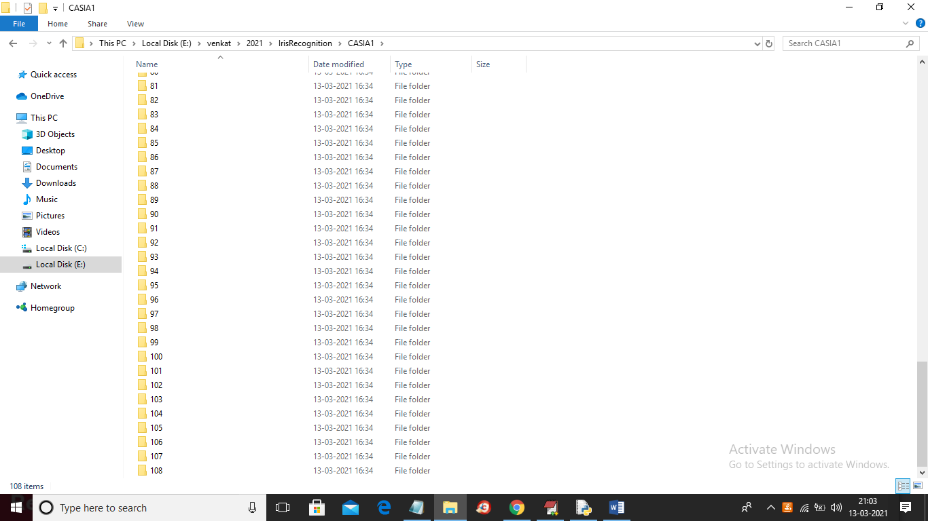

In above screen we have IRIS images from 108 peoples and just go inside any folder to get that person IRIS images like below screen

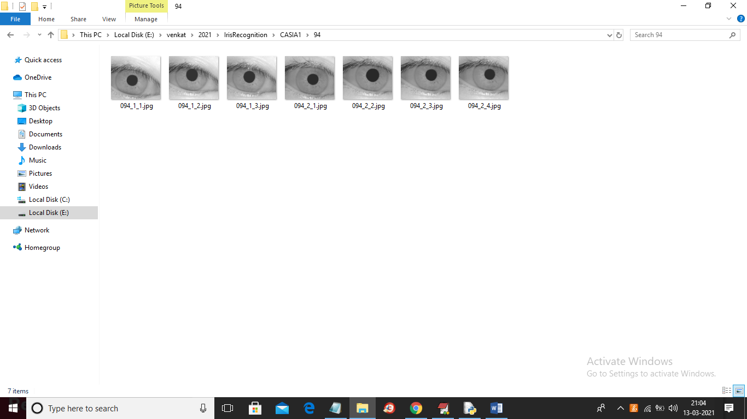

SCREEN SHOTS

To run project double click on ‘run.bat’ file to get below screen

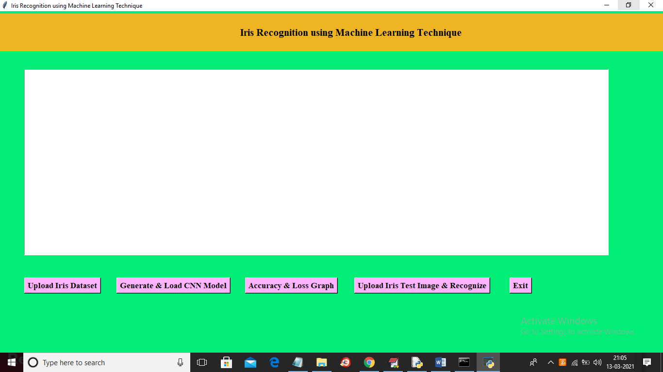

In above screen click on ‘Upload Iris Dataset’ button and upload dataset folder

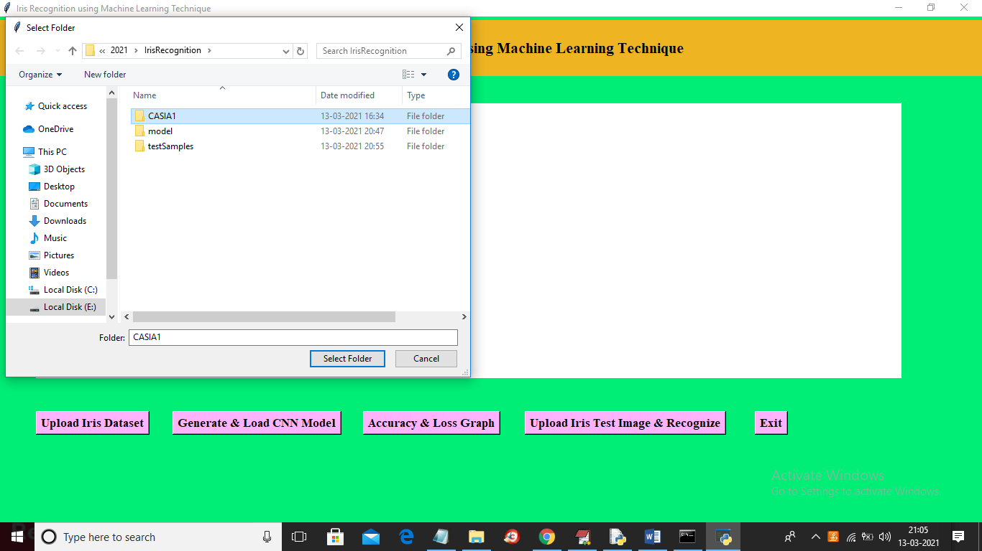

In above screen selecting and uploading ‘CASIA1’ folder and then click on ‘Select Folder’ button to load dataset and to get below screen

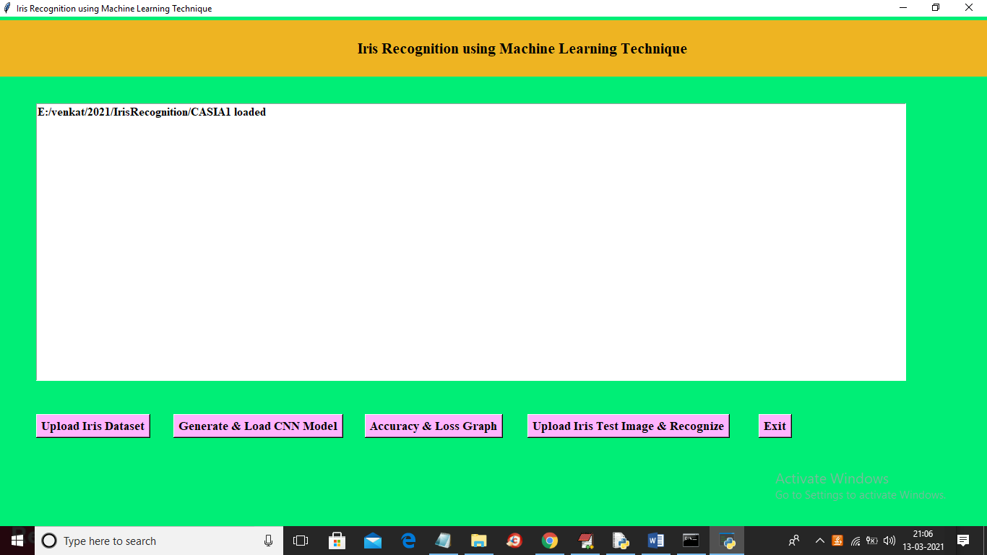

In above screen dataset loaded and now click on ‘Generate & Load CNN Model’ button to generate CNN model from loaded dataset

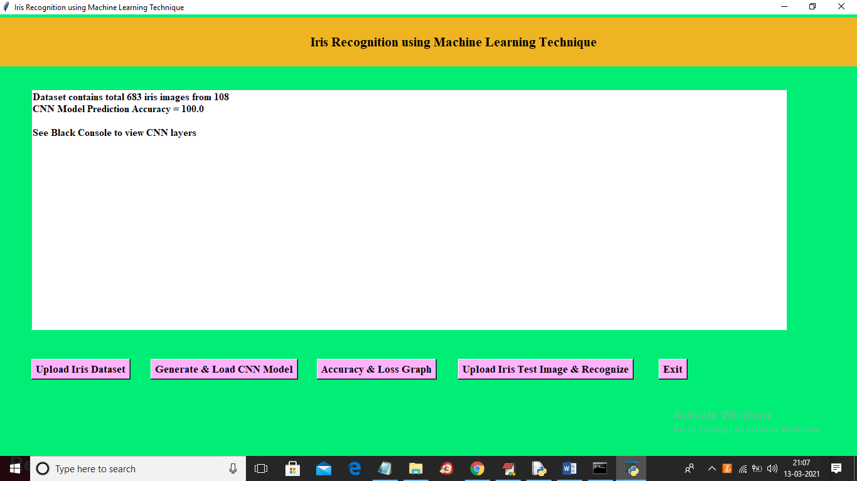

In above screen 683 images loaded from different 108 peoples and we got it prediction accuracy as 100%. Now model is ready and now click on ‘Accuracy & Loss Graph’ button to get below graph

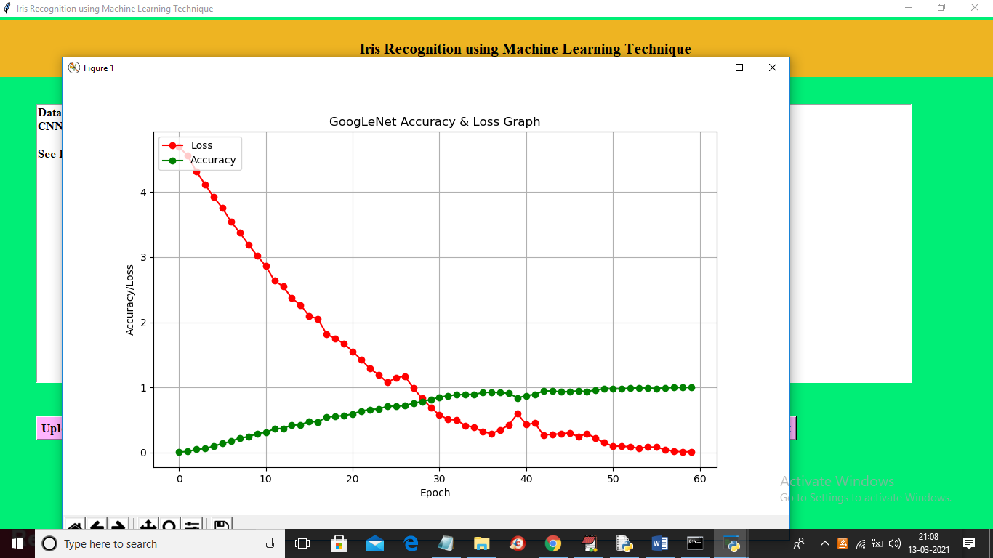

In above graph red line represents CNN model loss value and we can see at first iteration loss was more than 4% and when epoch increases then LOSS value reduce to 0 and green line represents accuracy and at first iteration accuracy was 0% and when epoch/iterations of model increases then accuracy reached to 100% and in above graph x-axis represents EPOCH and y-axis represents accuracy and loss values. Now click on ‘Upload Iris Test Image & Recognize’ button and upload any test image and then CNN will recognize person ID from that IRIS image. If you want you can upload test image from CASIA folder also and you will see prediction will be 100% correct

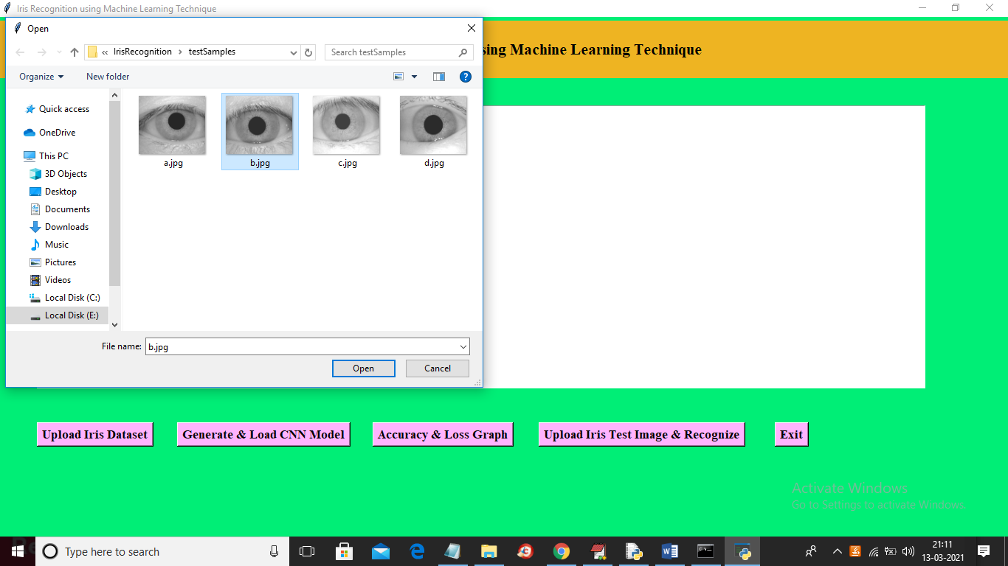

In above screen selecting and uploading ‘b.jpg’ file and then click on ‘Open’ button to get below screen

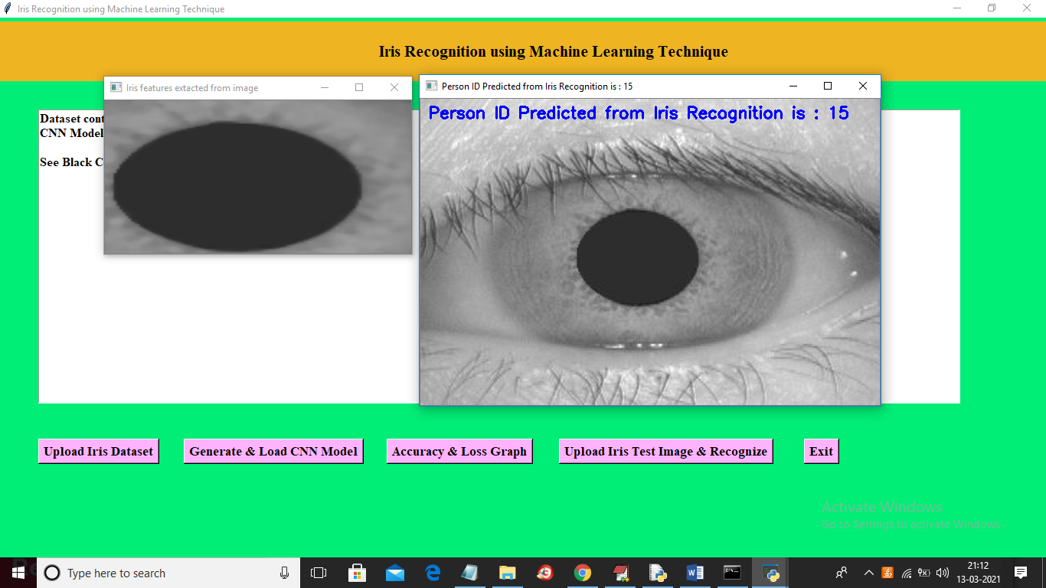

In above screen from uploaded image we extract IRIS features which is displaying in first image and then this image feeds to CNN and then CNN predicted that IRIS belong to person ID 15. Now I will upload one image from CASIA folder and then test whether CNN will predict correctly or not

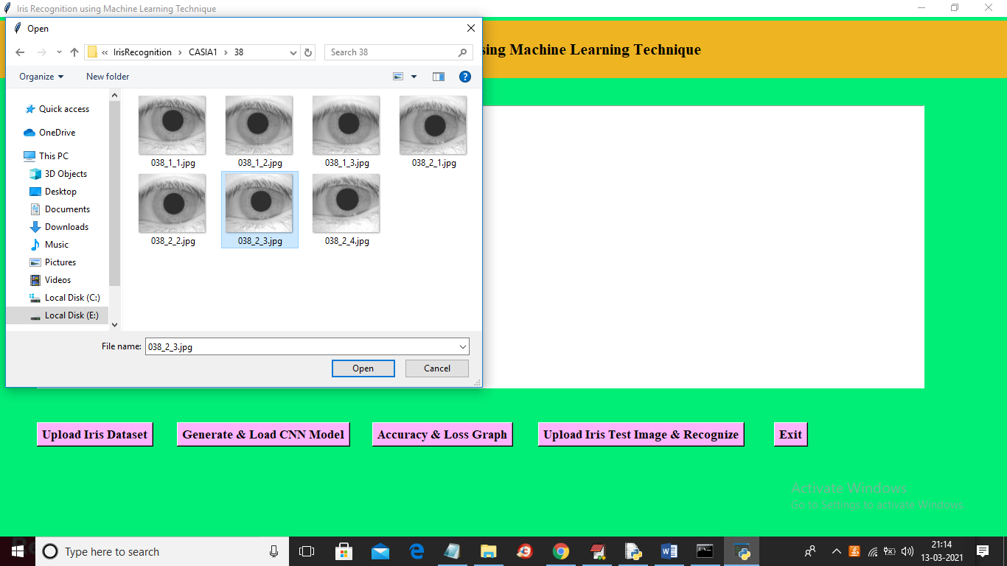

In above screen from CASIA folder I am uploading IRIS of person ID 38 and then click ‘Open’ button to get below result

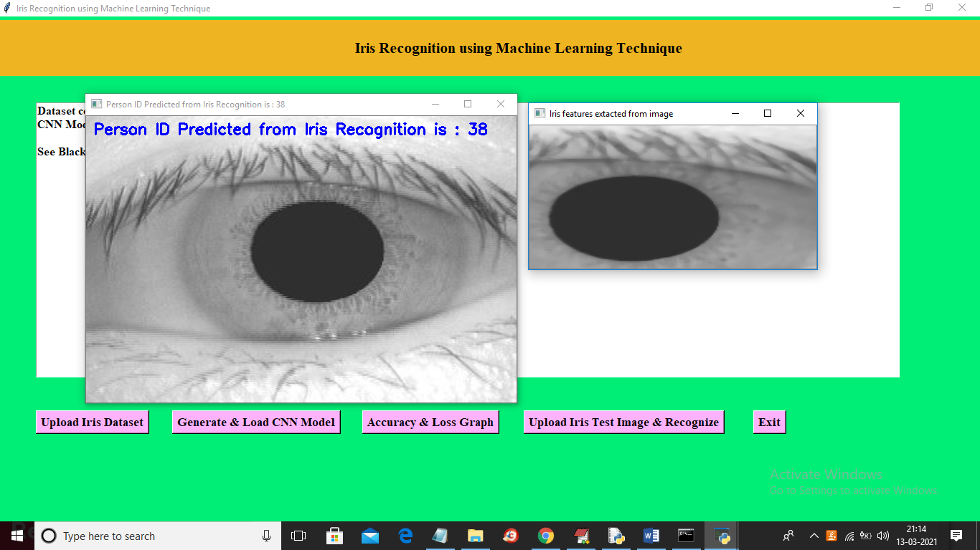

In above screen CNN predicted ID is 38 which is 100% correct